Technical Review Assessment

For an Intrusion Detection System using a Neural Network

Version 1.0

Submitted in partial fulfillment of the requirements of the degree of MSE

Blake Knedler

CIS 895 – MSE Project

Kansas State University

Table of Contents

1 Introduction 3

2 Assessment 3

3 Inspection Checklists 4

3.1 Checklist by Tracy Marshall 4

3.2 Checklist by Keith Moyer 5

# Introduction

This document will assess the technical reviews for the Intrusion Detection System (IDS). This document will analyze any failing points within the Technical Inspection Checklist given to both Tracy Marsahll and Keith Moyer. Any failing points will also be given an action plan to fix the issue that is found.

# Assessment

The technical inspections had no failing cases so no further action is needed. However, some comments mentioned suggestions to improve which will try to be implemented in the final product of the IDS.

# Inspection Checklists

## Checklist by Tracy Marshall

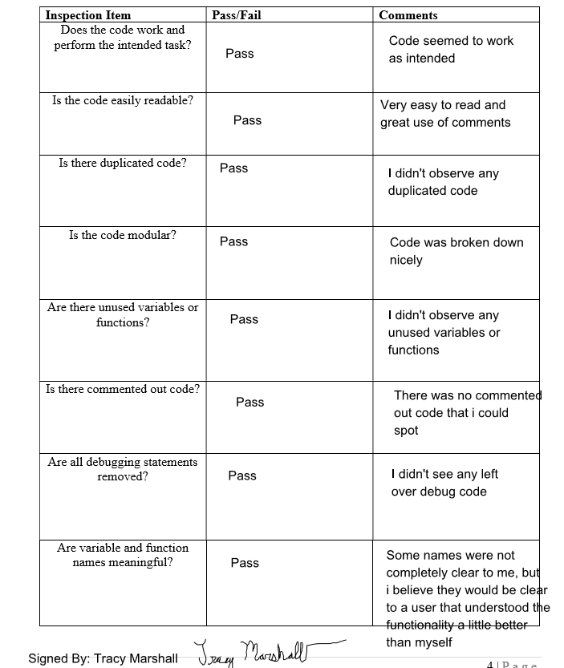

## Checklist by Keith Moyer

